Algorithm IN-order  (tree LRTR)  1. LEFT  2. ROOT  3. RIGHT | 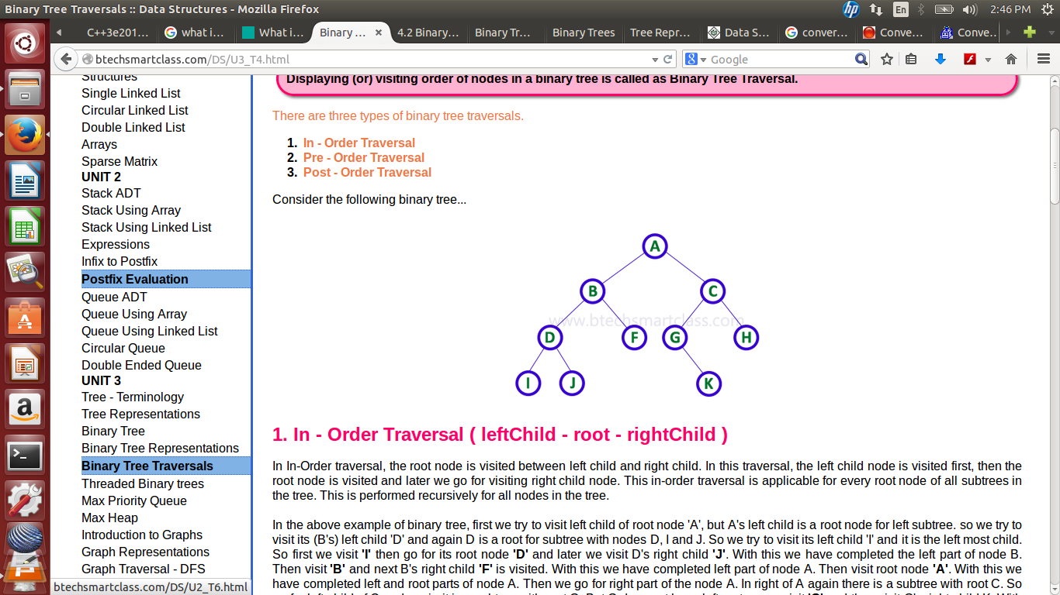
I-D-J-B-F-A-G-K-C-H

Algorithm PRE-order
(tree RTLR)
1. ROOT
2. LEFT
3. RIGHT

A-B-D-I-J-F-C-G-K-H

Algorithm POST-order
(tree LRRT)
1. LEFT
2. RIGHT
3. ROOT

I-J-D-F-B-K-G-H-C-A

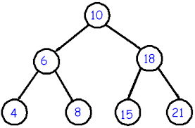

POSTORDER
4-8-6-15-21-18-10
INORDER
4-6-8-10-15-18-21
PRE ORDER
10-6-4-8-18-15-21

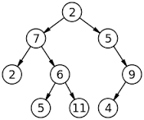

POST ORDER
2-5-11-6-7-4-9-5-2
IN-ORDER
2-7-5-6-11-2-5-4-9
PRE ORDER
2-7-2-6-5-11-5-9-4

